
SAFEX-SOLUTIONS

Week 4 Security Assessment Report
Clickjacking Detection Tool —

SUBMITTED BY:SHEEZA SAJID
GROUP 2- RED TEAMING

1. Objective
This assessment evaluates whether the HR-style demo lab application is protected against Clickjacking attacks. A custom Python-based detection tool was designed and built to automate the manual research and testing process into a reusable scanner that checks target URLs for the presence and correctness of clickjacking-related HTTP response headers.

2. Scope & Authorization
Testing was performed exclusively against a self-hosted lab application running locally at http://127.0.0.1:5000/, built specifically as the authorized test target for this exercise. No external, production, or third-party systems were scanned or accessed at any point during this assessment.

3. Methodology
- Researched Clickjacking: root cause, real-world exploitation technique, and standard remediation (X-Frame-Options / CSP frame-ancestors).
- Reviewed existing open-source header-scanning approaches to inform detection logic design.
- Designed detection logic based on presence/value of the X-Frame-Options header and the CSP frame-ancestors directive.
- Built a Python tool (clickjack_detector.py) that accepts a list of authorized URLs and scans each one.
- Logged results per URL: vulnerability status, severity, evidence, and remediation guidance.
- Tested the tool against the lab target to confirm true positives, and against a hardened endpoint to confirm no false positives.
- Generated this report summarizing findings, evidence, and remediation.

4. Tool Used
clickjack_detector.py — a custom Python scanner (Python 3, requests library) built for this assignment. Source code and usage instructions are included in the accompanying GitHub repository.

5. Findings Summary
Target URL | Status Code | X-Frame-Options | CSP frame-ancestors | Vulnerable | Evidence
http://127.0.0.1:5000/ | 200 | Not present | Not present | Yes (High) | No X-Frame-Options header and no CSP frame-ancestors directive returned in the response.
http://127.0.0.1:5000/clicks | 200 | Not present | Not present | Yes (High) | Page containing the click-tracking table is also framable; no clickjacking headers set.

6. Severity & Remediation

Finding: Missing Clickjacking Protection (High)
Both tested pages returned no X-Frame-Options header and no Content-Security-Policy frame-ancestors directive. This means the pages can be embedded inside an <iframe> on an attacker-controlled page, allowing a classic clickjacking overlay attack where a victim's click is hijacked.

Recommended Fix
- Add the response header: X-Frame-Options: DENY (or SAMEORIGIN if the app legitimately needs to frame itself).
- In addition, set a Content-Security-Policy header with frame-ancestors 'self' (modern browsers prioritize CSP over X-Frame-Options).
- Re-run the detection tool after the fix to confirm the finding is resolved (regression check).

7. True/False Positive Validation
- True positive check: tool correctly flagged the unprotected lab target as Vulnerable (High) when no headers were set.
- False positive check: when X-Frame-Options: DENY was manually added to a test response, the tool correctly classified the target as Safe.

8. Known Limitations
- The tool checks HTTP response headers only; it does not perform an actual iframe embed/exploit (by design — detection only).
- Does not validate the specific origin list inside a deprecated X-Frame-Options: ALLOW-FROM value beyond presence.
- Does not account for JavaScript-based frame-busting scripts; header-based detection reflects current best practice.
- Single-threaded design — suitable for a small number of authorized lab URLs, not large-scale scanning.

9. Deliverables Checklist
Done | Checklist Item
[x] | Only authorized lab environments tested
[x] | Detection logic tested for true and false positives
[x] | Report includes evidence, severity, and remediation for each finding
[x] | Tool is reusable against a new list of authorized URLs
[x] | Limitations clearly documented
[x] | Code and report pushed to GitHub

10. Manual Proof-of-Concept Demonstration
In addition to the automated header scan, a manual proof-of-concept was built to demonstrate real-world exploitability. A companion Flask page ("Click Records") logs every link click with a timestamp and source IP. When the lab target is embedded inside a transparent iframe overlay on an attacker-controlled page, a victim's click on what appears to be a harmless button is silently forwarded to the underlying page — and captured in the Click Records log below, confirming the click was successfully hijacked.

Click Records Log (Evidence)
Link: google — 2026-09-18 22:40:40 — Source IP: 127.0.0.1
Link: youtube — 2026-09-18 22:49:55 — Source IP: 127.0.0.1
Link: github — 2026-09-18 22:49:59 — Source IP: 127.0.0.1
Link: github — 2026-09-18 22:50:03 — Source IP: 127.0.0.1
This log demonstrates that clicks intended for the visible overlay were successfully captured by the underlying framed page, validating the header-based findings in Section 5 through an actual exploitation scenario rather than header inspection alone.
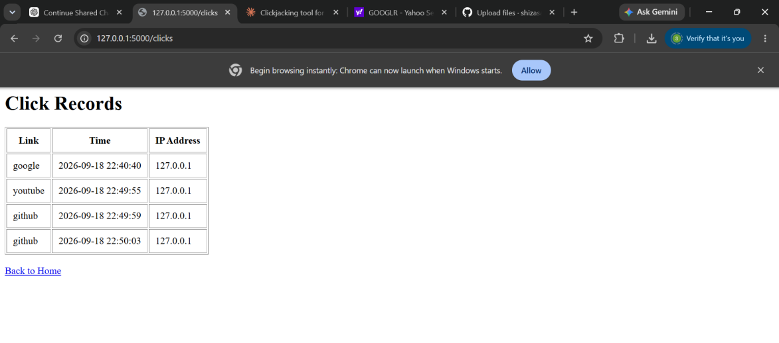
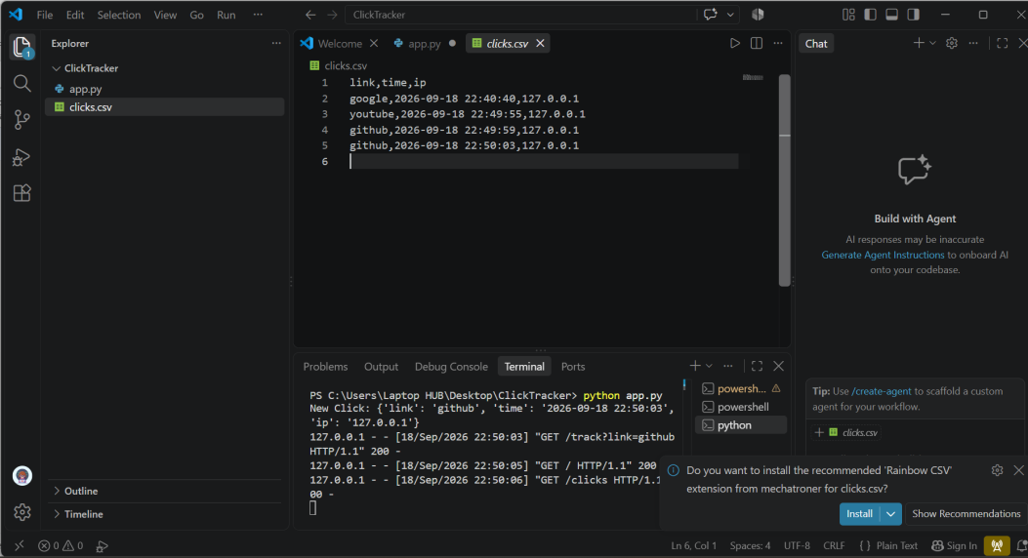

11. Conclusion
The lab target currently lacks clickjacking protections on both tested endpoints. Implementing the X-Frame-Options and CSP frame-ancestors headers as recommended will remediate the High-severity findings identified in this assessment. The detection tool built for this exercise is reusable and can be re-run against any new list of authorized URLs to verify remediation or extend coverage.

Appendix A: Detection Tool Source Code (clickjack_detector.py)
Full source code is maintained in the project's GitHub repository. Key excerpt of the detection logic:
if not xfo and not frame_ancestors:
result["vulnerable"] = True
result["severity"] = "High"
result["evidence"] = "No X-Frame-Options header and no CSP frame-ancestors directive present."
elif xfo and xfo.upper() not in ("DENY", "SAMEORIGIN"):
result["vulnerable"] = True
result["severity"] = "Medium"
else:
result["vulnerable"] = False
result["severity"] = "None"
GITHUB LINK:https://github.com/shizasajid62-gif/CLICKJACKING-DETECTION-TOOL

